|  |
| --- |
| **Crystal healing quartz** |

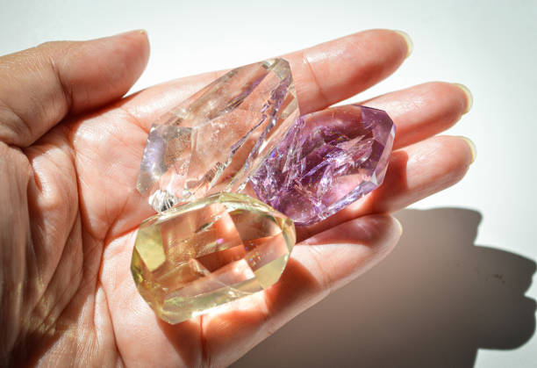

Quartz is one of the most popular and versatile stones used in crystal healing. It's often referred to as the "master healer" due to its wide-ranging properties. Here’s a breakdown of key details about quartz and its healing qualities: